**DAILY ONLINE ACTIVITIES SUMMARY**

|  |  |  |  |  |  |  |  |
| --- | --- | --- | --- | --- | --- | --- | --- |
| **Date:** | **12/06/2020** | | | | **Name:** | **Syed Rabeya Aamir** | |
| **Sem & Sec** | **8th B** | | | | **USN:** | **4AL16CS112** | |
| Online Test Summary | | | | | | | |
| **Subject** | | **BDA** | | | | | |
| **Max. Marks** | | **30** | | **Score** | | **25** | |
| Certification Course Summary | | | | | | | |
| **Course** | **DRIVEN BY REINFORCEMENT LEARNING.** | | | | | | |
| **Certificate Provider** | | | **Aws** | **Duration** | | | **6 hrs** |
| Coding Challenges | | | | | | | |
| **Problem Statement:**  **1)** Python program to remove duplicate elements from a list. | | | | | | | |
| **Status: Solved** | | | | | | | |
| **Uploaded the report in Github** | | | | **YES** | | | |
| **If yes Repository name** | | | | **rabeya** | | | |
| **Uploaded the report in slack** | | | | **YES** | | | |

**Online Test:**

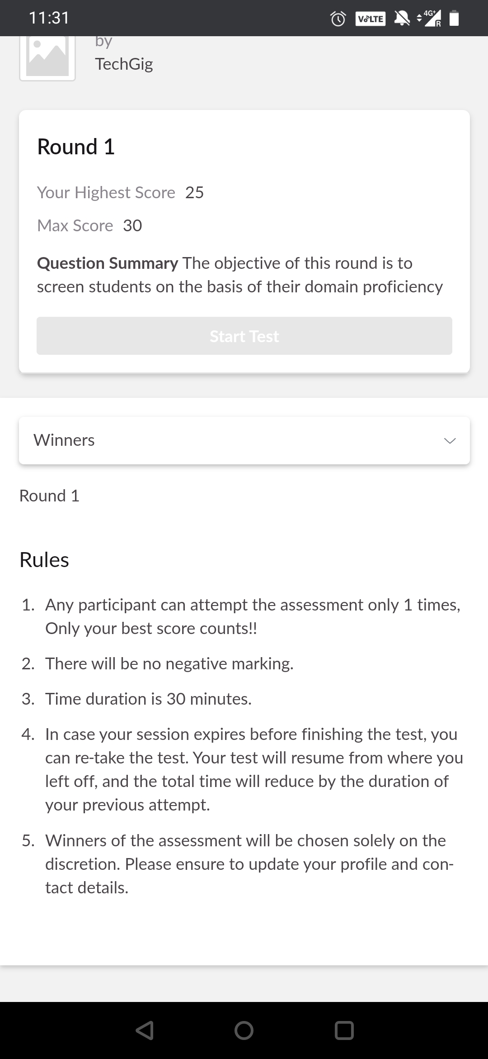

**Certification Course Details:**

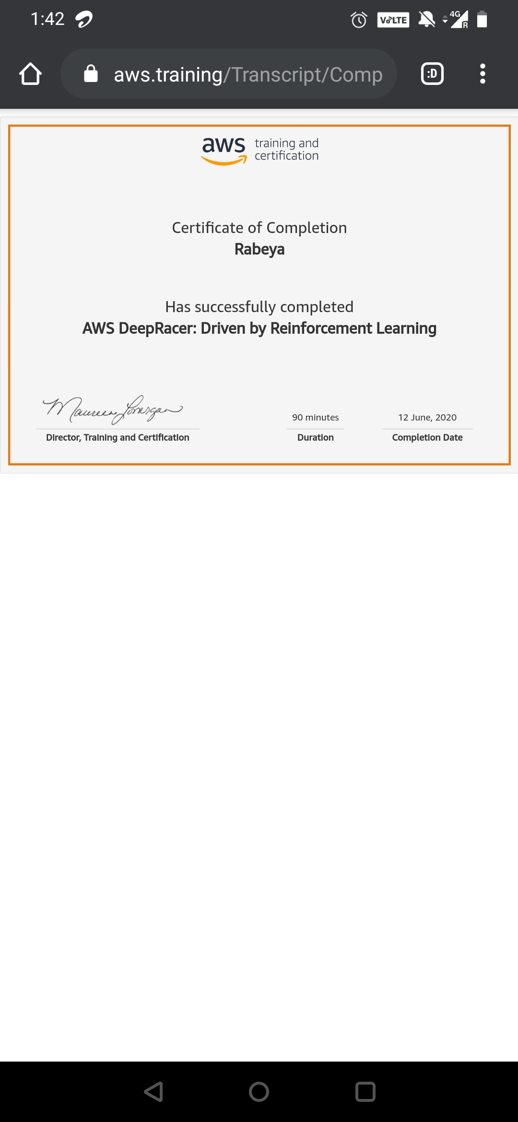

# CODE:

Program no:1

# Python program to remove duplicate elements from a list

n = int(input())

elements = []

for i in range(0, n):

elements.append(int(input()))

result = list(sorted(set(elements)))

print(result)